**COLONIAL NEWS**

Health Committee Newsletter DECEMBER 2024

Welcome to the Albert Gallatin School District Health Committee’s monthly newsletter. Each month this publication will provide our district with health and fitness information. Our goal is for our students, families, and staff to use this information to make healthy decisions and to live a healthy active lifestyle.

## Winter Weather Safety

Winter storms are dangerous but there are steps you can take to prepare for the possibility of winter storms that may cause power outages.

Below is a basic list of items to have on hand in the event of a power outage during a winter storm.

* Canned fruits and vegetables (have a manual can opener on hand)
* Crackers, nuts, fruit bars
* Bottled water
* Disposable plates, bowls and utensils
* Portable radio and batteries
* Warm clothing – hats, mittens, winter coats
* Extra blankets and/or sleeping bags
* Flashlights and batteries
* First aid kit

During winter storms it is best to stay inside your home. Cold temperatures and high winds allow frostbite and hypothermia to set in quickly if you are outside. You can conserve heat in your home by avoiding any unnecessary opening of doors or windows, closing off unneeded rooms, stuffing towels or rags in cracks under doors, and closing draperies at night.

For more information visit [www.weather.gov](http://www.weather.gov) and [www.cdc.gov](http://www.cdc.gov)

(Adapted from Sources: CDC and National Weather Service)



**Seasonal Affective Disorder (SAD)**

Seasonal affective disorder (SAD) is a type of depression that’s related to the change in seasons. Most people with SAD experience symptoms that start in late fall or early winter and go away during the spring and summer months. However, while less often, other people may experience depressive symptoms during the spring and summer months. Sometimes these mood changes are more serious and can affect how a person feels, thinks, and behaves. If you notice significant changes in your behavior or mood when the seasons change, you may be experiencing SAD.

**SAD Symptoms**

* Persistent anxious, sad, or “empty” mood most of the day, nearly every day, for at least 2 weeks.
* Feelings of irritability, frustration, or restlessness.
* Feelings of pessimism, guilt, hopelessness, helplessness, or worthlessness.
* Loss of interest or pleasure in hobbies and activities or social withdrawal.
* Decreased energy and fatigue.
* Difficulty concentrating or making decisions.
* Changes in sleep and/or appetite.
* Physical aches or pains, headaches, or digestive issues that do not have a clear physical cause.
* Thoughts of death or suicide or suicide attempts

**Managing SAD**

Treatment for SAD falls into four main categories that can be used alone or in combination with one another:

* **Light therapy:** Sitting in front of a very bright light box first thing in the morning for about 30-40 minutes a day from fall to spring.
* **Psychotherapy:** Psychotherapy, also called talk therapy or counseling, teaches new ways of thinking and behaving and changing habits that contribute to depression.
* **Antidepressant medication:** Medications used to treat depression (antidepressants) can be effective for SAD when used alone or in combination with talk therapy.
* **Vitamin D:** Because many people with winter pattern SAD have vitamin D deficiency, vitamin D supplements may help improve

symptoms. Talk with a health care provider about any dietary supplements and prescriptions or over the counter medications you are taking, as vitamin D can interact with certain medications.

Source: ACSHIC

Prepared by Lisa Sumey, Central Office Secretary

**Recipe of the Month**

**Chicken ‘n Dumplings**

Ingredients:

* 1 whole chicken
* 1 pinch salt
* 1 lemon, halved
* 2 stalks celery, sliced
* 1 small onion, chopped
* 2 carrots, sliced, or more to taste
* 2 cups all-purpose flour
* Salt and ground black pepper to taste

Directions:

1. Place chicken and 1 pinch salt in a large pot; cover with water. Bring to a boil, skimming any scum off the surface with a slotted spoon. Add lemon, celery, onion, and carrots. Simmer broth over medium heat until chicken starts to fall off the bone, about 1 hour.
2. Discard lemon. Remove chicken from the pot; let cool.
3. Place flour, salt, and pepper in a large bowl. Make a well in the center. Ladle in 2 to 3 scoops of hot broth. Mix in flour with a spoon until dough comes together into a ball.
4. Turn dough out onto a floured surface. Knead carefully until smooth. Roll out into a large rectangle; cut into small rectangular dumplings.
5. Drop dumplings one at a time into the simmering broth. Cook, stirring occasionally, until tender, about 30 minutes.
6. Bone chicken and chop into pieces. Add to the pot; cook until heated through, about 5 minutes.

   
  
  
  
   
  
 

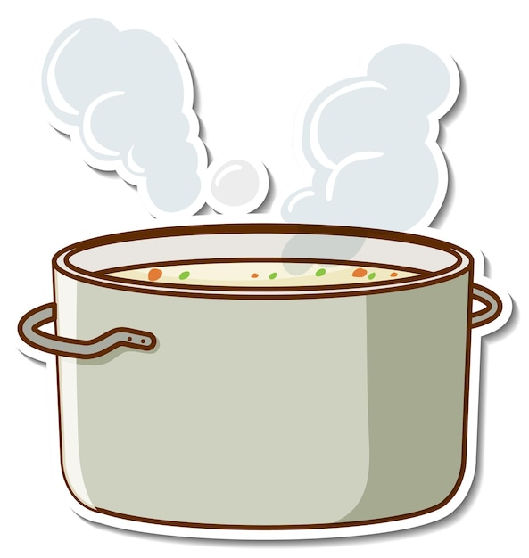

## Happy, Healthy Holiday Tips

While progressing through the holiday season, keep these tips in mind:

**Eat Well**

Holidays often center around food. Watch your portions by following the simple rule of filling half your plate with fruits and vegetables, one quarter with protein and one quarter with grains.

## **Stay Active**

When the chaos of the holiday leaves you short on time to do your regular exercise routine, aim to do at least one activity. Exercising for a short amount of time is better than not exercising at all.

## **Reduce Stress**

Plan ahead for your holiday preparations, take time to relax and do something you enjoy.

## **Be Healthy**

Get a good night’s sleep. It helps ward off winter colds and increases your energy.

Also remember to wash your hands to help you stay healthy during the cold and flu season. Wash your hands for at least 20 seconds with soap and water, dry with a clean towel or air dry them.

(Adapted from Source: HealthAdvocate)